Azure Machine Learning: Day 2

ML Notebook

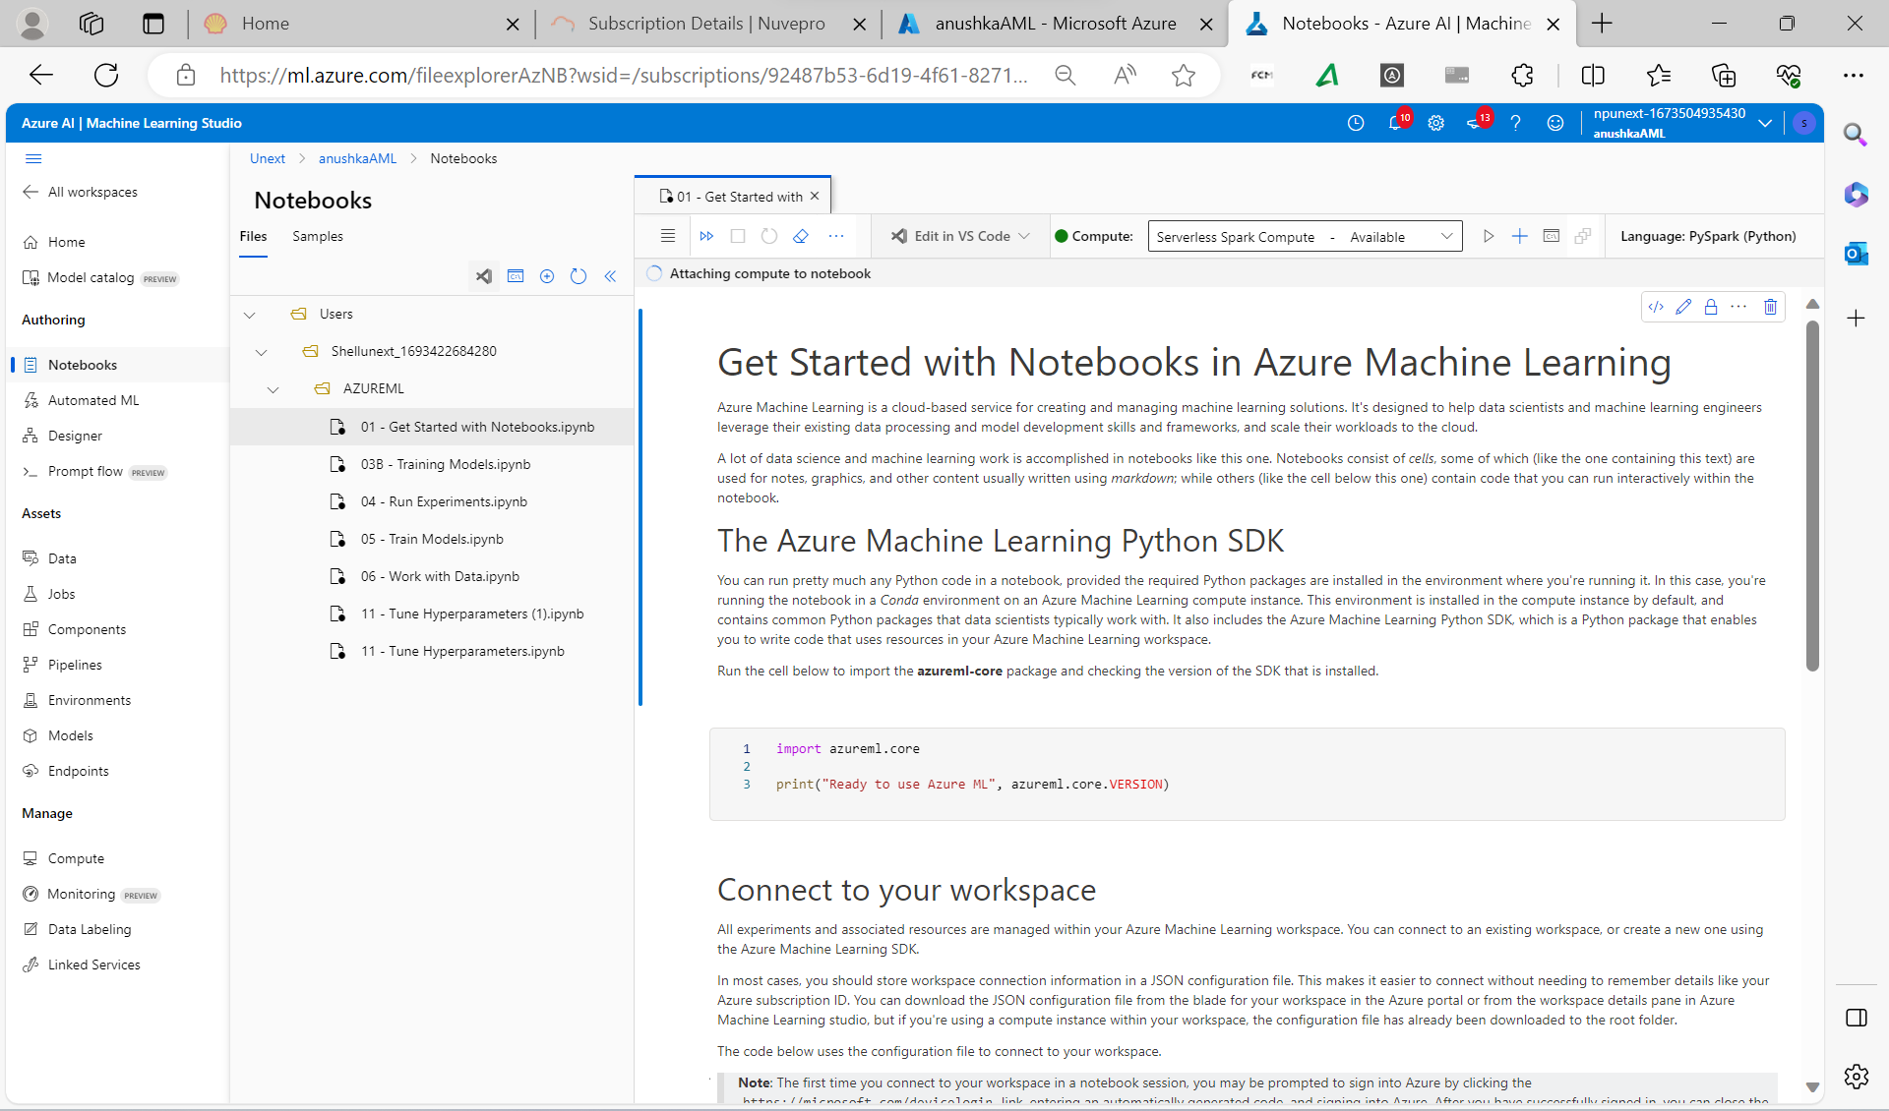

Cluster

ML Model: Movie Recommendation:

